C. Bouncing Ball
time limit per test
1 second
memory limit per test
256 megabytes
input
standard input
output
standard output
You're creating a game level for some mobile game. The level should contain some number of cells aligned in a row from left to right and numbered with consecutive integers starting from 11, and in each cell you can either put a platform or leave it empty.
In order to pass a level, a player must throw a ball from the left so that it first lands on a platform in the cell pp, then bounces off it, then bounces off a platform in the cell (p+k)(p+k), then a platform in the cell (p+2k)(p+2k), and so on every kk-th platform until it goes farther than the last cell. If any of these cells has no platform, you can't pass the level with these pp and kk.
You already have some level pattern a1a1, a2a2, a3a3, ..., anan, where ai=0ai=0 means there is no platform in the cell ii, and ai=1ai=1 means there is one. You want to modify it so that the level can be passed with given pp and kk. In xx seconds you can add a platform in some empty cell. In yy seconds you can remove the first cell completely, reducing the number of cells by one, and renumerating the other cells keeping their order. You can't do any other operation. You can not reduce the number of cells to less than pp.
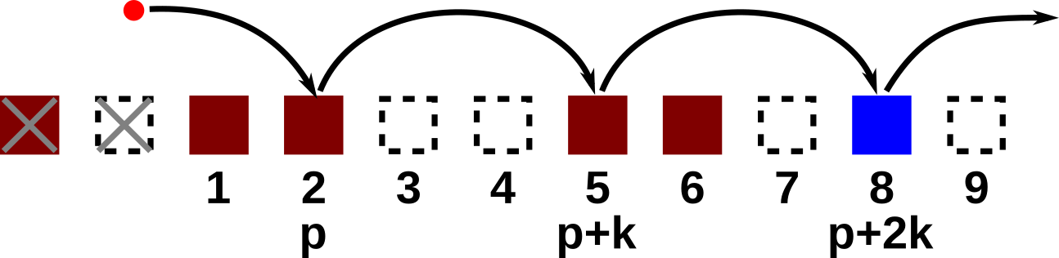Illustration for the third example test case. Crosses mark deleted cells. Blue platform is the newly added.
What is the minimum number of seconds you need to make this level passable with given pp and kk?
Input
The first line contains the number of test cases tt (1≤t≤1001≤t≤100). Description of test cases follows.
The first line of each test case contains three integers nn, pp, and kk (1≤p≤n≤1051≤p≤n≤105, 1≤k≤n1≤k≤n) — the number of cells you have, the first cell that should contain a platform, and the period of ball bouncing required.
The second line of each test case contains a string a1a2a3…ana1a2a3…an (ai=0ai=0 or ai=1ai=1) — the initial pattern written without spaces.
The last line of each test case contains two integers xx and yy (1≤x,y≤1041≤x,y≤104) — the time required to add a platform and to remove the first cell correspondingly.
The sum of nn over test cases does not exceed 105105.
Output
For each test case output a single integer — the minimum number of seconds you need to modify the level accordingly.
It can be shown that it is always possible to make the level passable.
Example
input
Copy
3
10 3 2
0101010101
2 2
5 4 1
00000
2 10
11 2 3
10110011000
4 3
output
Copy
2
4
10
Note
In the first test case it's best to just remove the first cell, after that all required platforms are in their places: 0101010101. The stroked out digit is removed, the bold ones are where platforms should be located. The time required is y=2y=2.
In the second test case it's best to add a platform to both cells 44 and 55: 00000 →→ 00011. The time required is x⋅2=4x⋅2=4.
In the third test case it's best to to remove the first cell twice and then add a platform to the cell which was initially 1010-th: 10110011000 →→ 10110011010. The time required is y⋅2+x=10y⋅2+x=10.
就是枚举从哪里开始删，然后求每个点后面是否每k个都是1.。
这样求。。。
我太菜了！！
#include<bits/stdc++.h>
#define ll long long
using namespace std;
const int N=1e5+10;
int dp[N];
int main()
{
int t;
scanf("%d",&t);
while(t--)
{
int n,p,k;
scanf("%d %d %d",&n,&p,&k);
string a;
cin>>a;
int x,y;
for(int i=1;i<=n;i++) dp[i]=0;
scanf("%d %d",&x,&y);
a=' '+a;
for(int i=n;i>=1;i--)
{
if(a[i]=='0') dp[i]=x;
if(i+k<=n) dp[i]+=dp[i+k];
}
int ans=0x3fffffff;
for(int i=p;i<=n;i++)
{
ans=min(ans,(dp[i]+(i-p)*y));
}
printf("%d\n",ans);
}
return 0;
}

